Chapter 5: Matrix approach to simple linear regression analysis

You need to understand matrix algebra for multiple regression! Fox’s Section 8.2 contains information about how to use R for matrix algebra.

5.1 Matrices

What is a matrix?

“A matrix is a rectangular array of elements arranged in rows and columns” (p. 176 of KNN)

Example:
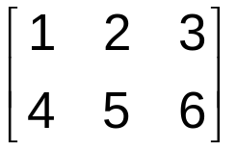

Dimension – Size of matrix: # rows × # columns = r×c

Example: 2×3

Symbolic representation of a matrix:

Example:
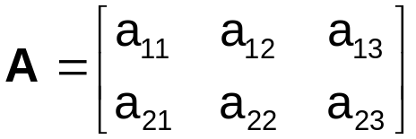
where a_{ij} is the row i and column j element of A

a₁₁=1 from the above example

Notice that the matrix A is in bold. When bolding is not possible (writing on a piece of paper or chalkboard), the letter is underlined - A

a₁₁ is often called the “(1,1) element” of A, a₁₂ is called the “(1,2) element” of A,…

Example: r×c matrix
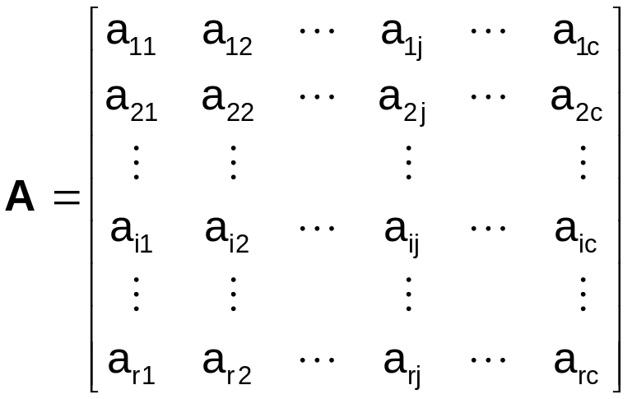

Example: Square matrix is r×c where r=c

Example: HS and College GPA
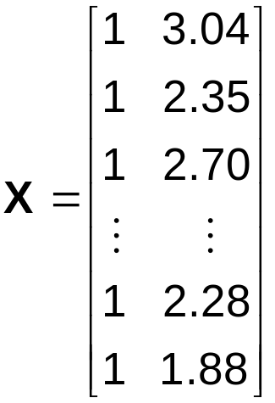
The above 20×2 matrix contains the HS GPAs in the second column.

Vector – a r×1 (column vector) or 1×c (row vector) matrix – special case of a matrix

Example: Symbolic representation of a 3×1 column vector
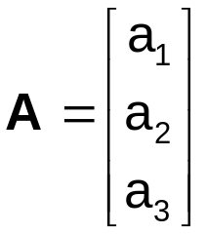

Example: HS and College GPA
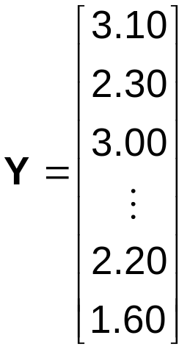
The above 20×1 vector contains the College GPAs.

Transpose: Interchange the rows and columns of a matrix or vector

Example:
and 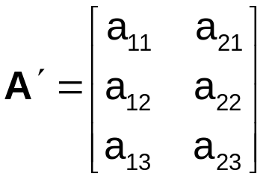
A is 2×3 and A′ is 3×2

The ′ symbol indicates a transpose, and it is said as the word “prime”. Thus, the transpose of A is “A prime”.

Example: HS and College GPA

5.2 Matrix addition and subtraction

Add or subtract the corresponding elements of matrices with the same dimension.

Example:
Suppose 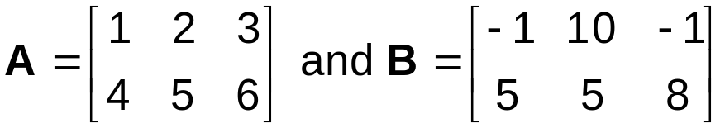. Then 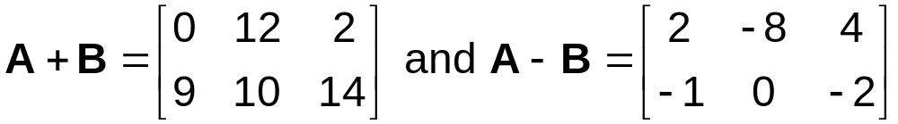.

Example: Using R (basic_matrix_algebra.R)

> A<-matrix(data = c(1, 2, 3,
4, 5, 6), nrow = 2, ncol = 3, byrow =
TRUE)

> class(A)
[1] "matrix"

> B<-matrix(data = c(-1, 10, -1, 5, 5, 8), nrow = 2, ncol =
3, byrow = TRUE)

> A+B
[,1] [,2] [,3]
[1,] 0 12 2
[2,] 9 10 14

> A-B
[,1] [,2] [,3]
[1,] 2 -8 4
[2,] -1 0 -2

Notes:
- Be careful with the byrow option. By default, this is set to FALSE. Thus, the numbers would be entered into the matrix by columns. For example,

> matrix(data = c(1, 2, 3, 4, 5, 6), nrow = 2, ncol = 3)
[,1] [,2] [,3]
[1,] 1 3 5
[2,] 2 4 6

- The class of these objects is “matrix”.
- A vector can be represented as a “matrix” class type or a type of its own.

> y<-matrix(data = c(1,2,3), nrow = 3, ncol = 1, byrow
= TRUE)
> y
[,1]
[1,] 1
[2,] 2
[3,] 3
> class(y)
[1] "matrix"

> x<-c(1,2,3)
> x
[1] 1 2 3
> class(x)
[1] "numeric"
> is.vector(x)
[1] TRUE

This can present some confusion when vectors are multiplied with other vectors or matrices because no specific row or column dimensions are given. More on this shortly.
- A transpose of a matrix can be done using the t() function. For example,

> t(A)
[,1] [,2]
[1,] 1 4
[2,] 2 5
[3,] 3 6

Example: Simple linear regression model

Y_{i}=E(Y_{i}) + ε_{i} for i=1,…,n can be represented as
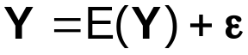 where

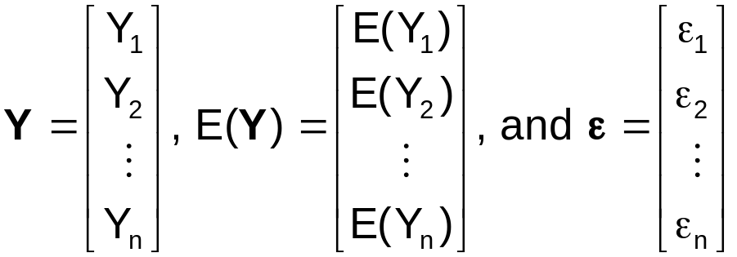

5.3 Matrix multiplication

Scalar - 1×1 matrix

Example: Matrix multiplied by a scalar

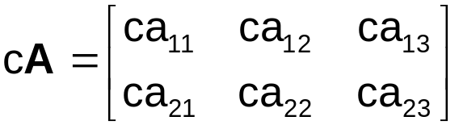 where c is a scalar

Let 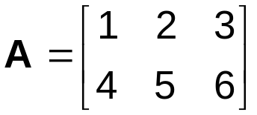 and c=2. Then 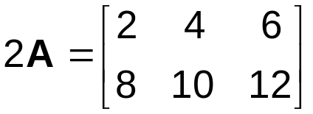.

Multiplying two matrices

Suppose you want to multiply the matrices A and B; i.e., A∗B or AB. In order to do this, you need the number of columns of A to be the same as the number of rows as B. For example, suppose A is 2×3 and B is 3×10. You can multiply these matrices. However if B is 4×10 instead, these matrices could NOT be multiplied.

The resulting dimension of C=AB
- The number of rows of A is the number of rows of C.
- The number of columns of B is the number of rows of C.
- In other words, 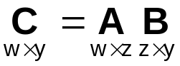 where the dimension of the matrices are shown below them.

How to multiply two matrices – an example
Suppose 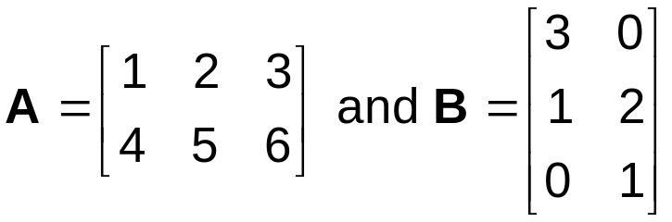. Notice that A is 2×3 and B is 3×2 so C=AB can be done.

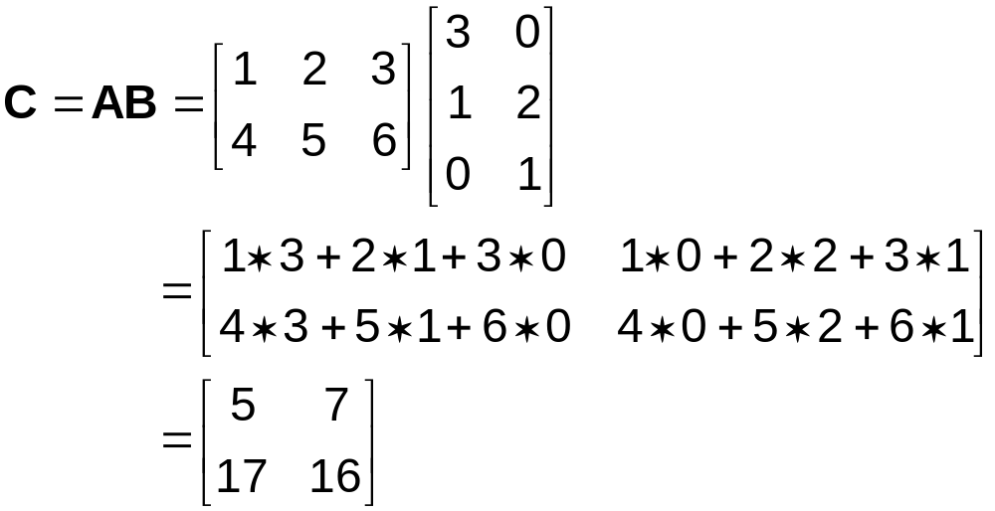

The “cross product” of the rows of A and the columns of B are taken to form C

In the above example, D=BA≠AB where BA is:
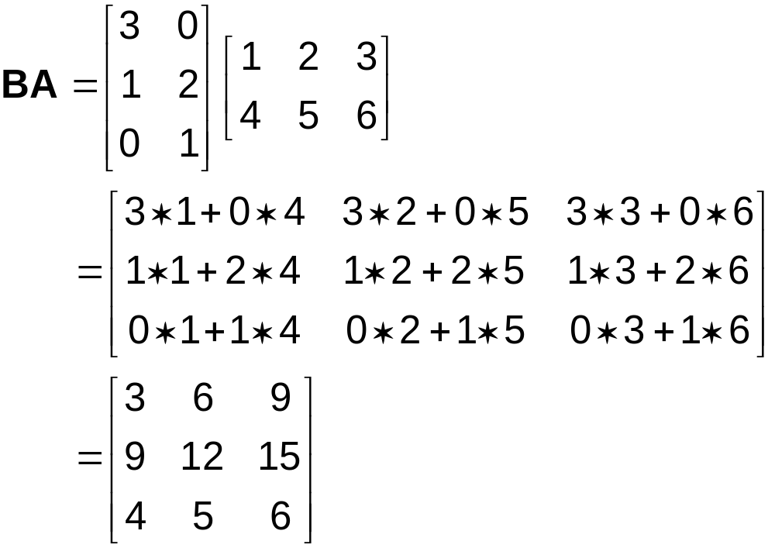

In general for a 2×3 matrix times a 3×2 matrix:

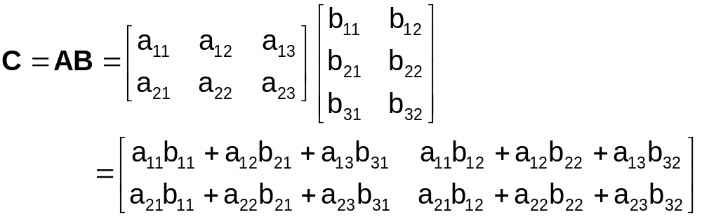

Example: Using R (basic_matrix_algebra.R)

> A<-matrix(data = c(1, 2, 3, 4, 5, 6), nrow = 2, ncol =
3, byrow = TRUE)
> B<-matrix(data = c(3, 0, 1, 2, 0, 1), nrow = 3, ncol =
2, byrow = TRUE)

> C<-A%*%B
> D<-B%*%A

> C
[,1] [,2]
[1,] 5 7
[2,] 17 16

> D
[,1] [,2] [,3]
[1,] 3 6 9
[2,] 9 12 15
[3,] 4 5 6

> #What is A*B?
> A*B
Error in A * B : non-conformable arrays

Notes:
- %*% is used for multiplying matrices and/or vectors
- * means to perform elementwise multiplications. Here is an example where this can be done:

> E<-A
> A*E
[,1] [,2] [,3]
[1,] 1 4 9
[2,] 16 25 36

The (i,i) elements of each matrix are multiplied together.

- Multiplying vectors with other vectors or matrices can be confusing since no row or column dimensions are given for a vector object. For example, suppose x = 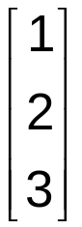, a 3×1 vector

> x<-c(1,2,3)
> x%*%x
[,1]
[1,] 14
> A%*%x
[,1]
[1,] 14
[2,] 32

How does R know that we want x′x (1×1) instead of xx′ (3×3) when we have not told R that x is 3×1? Similarly, how does R know that Ax is 2×1? From the R help for %*% in the Base package:

Multiplies two matrices, if they are conformable. If one argument is a vector, it will be promoted to either a row or column matrix to make the two arguments conformable. If both are vectors it will return the inner product.

An inner product produces a scalar value. If you wanted xx′ (3×3), one can use the outer product %o%

> x%o%x #outer product
[,1] [,2] [,3]
[1,] 1 2 3
[2,] 2 4 6
[3,] 3 6 9

We will only need to use %*% in this class.

Example: HS and College GPA (HS_college_GPA_ch5.R)

and

Find X′X, X′Y, and Y′Y

> #Read in the data
> gpa<-read.table(file =
"C:\\chris\\UNL\\STAT870\\Chapter1\\gpa.txt",
header=TRUE, sep = "")
> head(gpa)
HS.GPA College.GPA
1 3.04 3.1
2 2.35 2.3
3 2.70 3.0
4 2.05 1.9
5 2.83 2.5
6 4.32 3.7

> X<-cbind(1, gpa$HS.GPA)
> Y<-gpa$College.GPA

> X
[,1] [,2]
[1,] 1 3.04
[2,] 1 2.35
[3,] 1 2.70
[4,] 1 2.05
[5,] 1 2.83
[6,] 1 4.32
[7,] 1 3.39
[8,] 1 2.32
[9,] 1 2.69
[10,] 1 0.83
[11,] 1 2.39
[12,] 1 3.65
[13,] 1 1.85
[14,] 1 3.83
[15,] 1 1.22
[16,] 1 1.48
[17,] 1 2.28
[18,] 1 4.00
[19,] 1 2.28
[20,] 1 1.88

> Y
[1] 3.1 2.3 3.0 1.9 2.5 3.7 3.4 2.6 2.8 1.6 2.0 2.9 2.3
3.2 1.8 1.4 2.0 3.8 2.2
[20] 1.6

> t(X)%*%X
[,1] [,2]
[1,] 20.00 51.3800
[2,] 51.38 148.4634

> t(X)%*%Y
[,1]
[1,] 50.100
[2,] 140.229

> t(Y)%*%Y
[,1]
[1,] 135.15

Notes:
- The cbind() function combines items by “c”olumns. Since 1 is only one element, it will replicate itself for all elements that you are combining so that one full matrix is formed. There is also a rbind() function that combines by rows. Thus, rbind(a,b) forms a matrix with a above b.
- 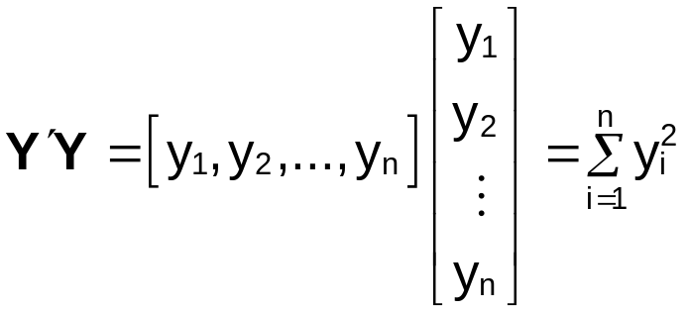
- 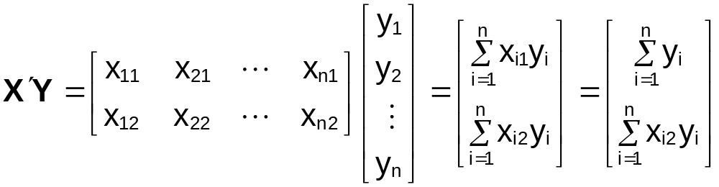 since x₁₁=…=x_{n1}=1
- X′X
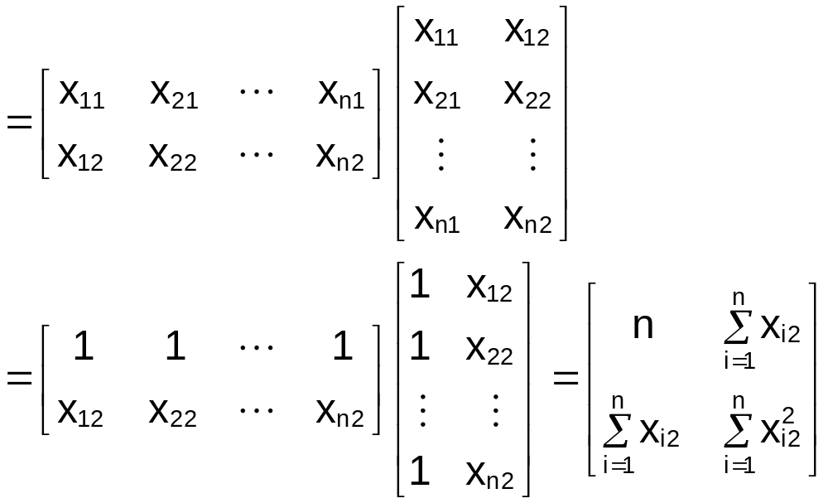
- Here’s another way to get the X matrix

> mod.fit<-lm(formula = College.GPA ~ HS.GPA, data =
gpa)
> model.matrix(object = mod.fit)
(Intercept) HS.GPA
1 1 3.04
2 1 2.35
3 1 2.70
4 1 2.05
5 1 2.83
6 1 4.32
7 1 3.39
8 1 2.32
9 1 2.69
10 1 0.83
11 1 2.39
12 1 3.65
13 1 1.85
14 1 3.83
15 1 1.22
16 1 1.48
17 1 2.28
18 1 4.00
19 1 2.28
20 1 1.88
attr(,"assign")
[1] 0 1

5.4 Special types of matrices

Symmetric matrix: If A=A′, then A is symmetric.

Example: 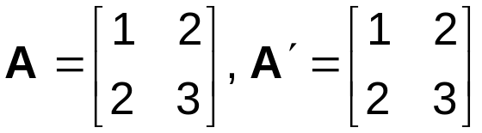

Diagonal matrix: A square matrix whose “off-diagonal” elements are 0.
Example: 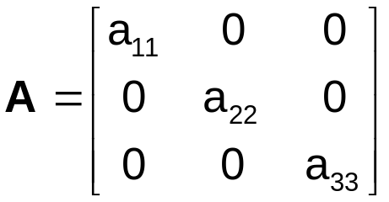

Identity matrix: A diagonal matrix with 1’s on the diagonal.
Example: 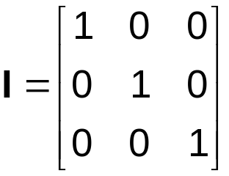
Note that “I” (the letter I, not the number one) usually denotes the identity matrix.

Vector and matrix of 1’s
A column vector of 1’s: 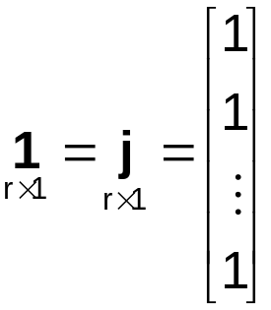
A matrix of 1’s: 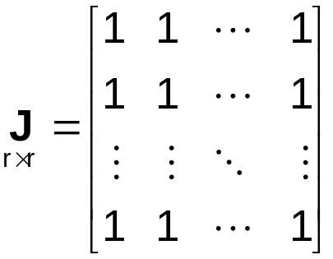
Notes:
- 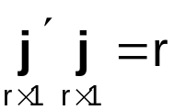
- 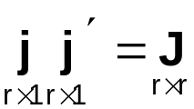
- 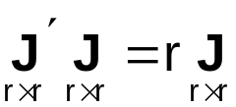
Vector of 0’s: 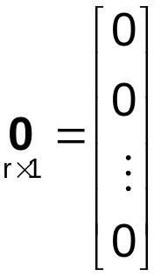

5.5 Linear dependence and rank of matrix

Let 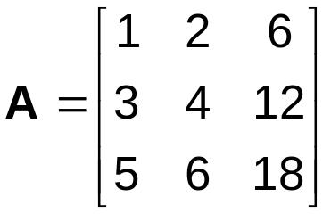. Think of each column of A as a vector; i.e., A = [A₁, A₂, A₃]. Note that 3A₂=A₃. This means the columns of A are “linearly dependent.”

Formally, a set of column vectors are linearly dependent if there exists constants λ₁, λ₂,…, λ_{n} (not all zero) such that λ₁A₁+λ₂A₂+…+λ_{c}A_{c}=0. A set of column vectors are linearly independent if λ₁A₁+λ₂A₂+…+λ_{c}A_{c}=0 only for λ₁=λ₂=…=λ_{c}=0 .

The rank of a matrix is the maximum number of linearly independent columns in the matrix.

rank(A)=2

5.6 Inverse of a matrix

Note that the inverse of a scalar, say b, is b⁻¹. For example, the inverse of b=3 is 3⁻¹=1/3. Also, b∗b⁻¹=1. In matrix algebra, the inverse of a matrix is another matrix. For example, the inverse of A is A⁻¹, and AA⁻¹=A⁻¹A=I. Note that A must be a square matrix.

Example: 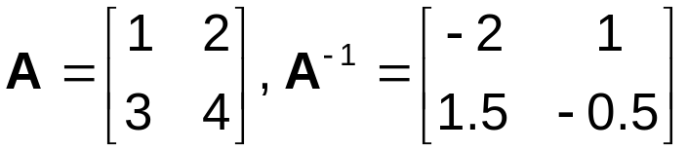
Check: 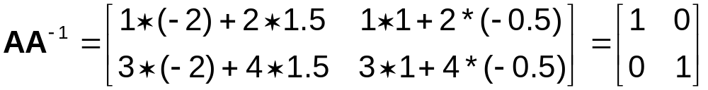

Finding the inverse

For a general way, see a matrix algebra book (such as: Kolman, 1988). For a 2×2 matrix, there is a simple formula. Let 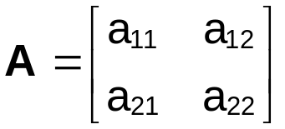. Then
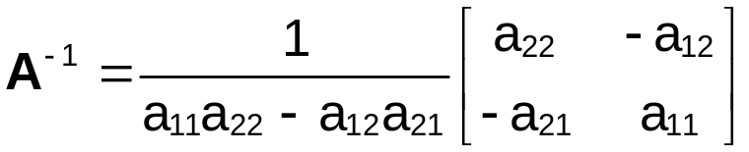.
Verify AA⁻¹=I on your own.

Example: Using R (basic_matrix_algebra.R)

> A<-matrix(data = c(1, 2, 3, 4), nrow = 2, ncol = 2,
byrow = TRUE)
> solve(A)
[,1] [,2]
[1,] -2.0 1.0
[2,] 1.5 -0.5

> A%*%solve(A)
[,1] [,2]
[1,] 1 1.110223e-16
[2,] 0 1.000000e+00

> solve(A)%*%A
[,1] [,2]
[1,] 1.000000e+00 0
[2,] 1.110223e-16 1

> round(solve(A)%*%A, 2)
[,1] [,2]
[1,] 1 0
[2,] 0 1

The solve() function inverts a matrix in R. The solve(A,b) function can also be used to “solve” for x in Ax = b since A⁻¹Ax = A⁻¹b ⇒ Ix = A⁻¹b ⇒ x = A⁻¹b

Example: HS and College GPA (HS_college_GPA_ch5.R)

Remember that and
Find (X′X)⁻¹ and (X′X)⁻¹X′Y

> solve(t(X)%*%X)
[,1] [,2]
[1,] 0.4507584 -0.15599781
[2,] -0.1559978 0.06072316

> solve(t(X)%*%X) %*% t(X)%*%Y
[,1]
[1,] 0.7075776
[2,] 0.6996584

From previous output:

> mod.fit<-lm(formula = College.GPA ~ HS.GPA, data = gpa)
> mod.fit$coefficients
(Intercept) HS.GPA
0.7075776 0.6996584

Note that (X′X)⁻¹X′Y = 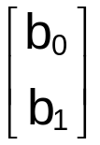!!!

> #Another way to get (X'X)^(-1)
> sum.fit<-summary(mod.fit)
> sum.fit$cov.unscaled
(Intercept) HS.GPA
(Intercept) 0.4507584 -0.15599781
HS.GPA -0.1559978 0.06072316

Read “Uses of Inverse Matrix” on p. 192 of KNN on your own.

5.7 Some basic theorems of matrices

Read on your own.

5.8 Random vectors and matrices

A random vector or random matrix contains elements that are random variables.

Example: Simple linear regression model

Y_{i}=E(Y_{i}) + ε_{i} for i=1,…,n can be represented as
where
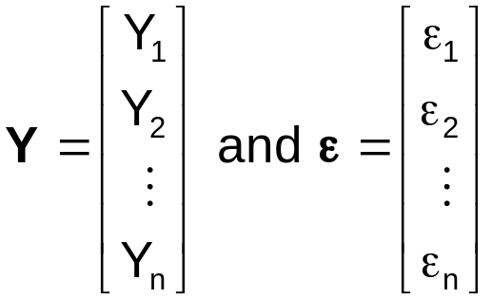 are random vectors.

Expectation of random vector or matrix: Find the expected value of the individual elements

Example:

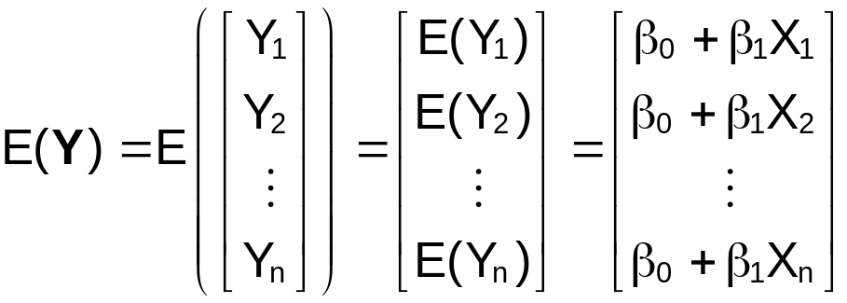

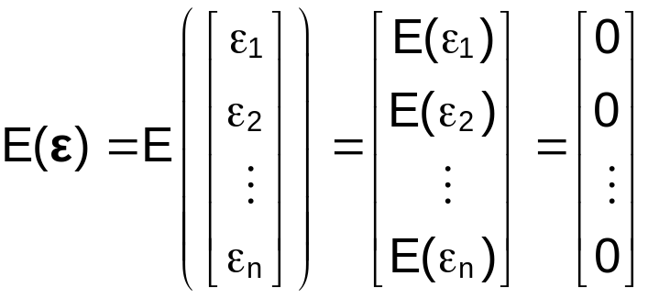 since we assume ε_{i}~N(0,σ²)

Variance-covariance matrix of a random vector

Let Z₁ and Z₂ be random variables. Remember that Var(Z₁)=E(Z₁-μ₁)² where E(Z₁)=μ₁.

The covariance of Z₁ and Z₂ is defined as Cov(Z₁,Z₂) = E[(Z₁-μ₁)(Z₂-μ₂)]. The covariance measures the relationship between Z₁ and Z₂. See p. 4.26 of my Chapter 4 STAT 380 notes for a more mathematical explanation (http://www.chrisbilder.com/
stat380/schedule.htm). Note that the correlation between Z₁ and Z₂ is

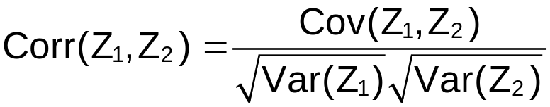.

The “Pearson correlation coefficient” which is denoted by r and estimates Corr(Z₁, Z₂)

Remember that 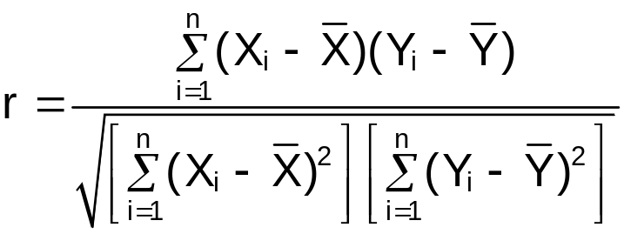 where X=Z₁ and Y=Z₂.

Notes:
- Cov(Z₁,Z₁)=E[(Z₁-μ₁)(Z₁-μ₁)]=E[(Z₁-μ₁)²]=Var(Z₁)
- If Z₁ and Z₂ are independent, then Cov(Z₁,Z₂)=0.

A variance-covariance matrix (most often just called the covariance matrix) is a matrix whose elements are the variances and covariances of random variables.

Example: Let 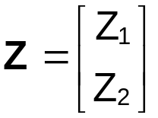. The covariance matrix of Z is

Cov(Z) = 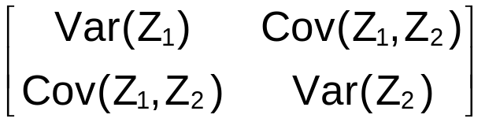
Note that Cov(Z₁,Z₂)=Cov(Z₂,Z₁) and Cov(Z_{i},Z_{i})=Var(Z_{i})

KNN denote Cov(Z) by σ²{Z}. The notation that I am using is much more prevalent and there is less chance for confusion (like Z being multiplied by σ² in σ²{Z}).

Example: Simple linear regression model

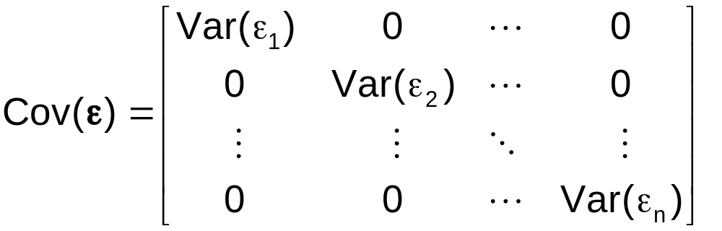
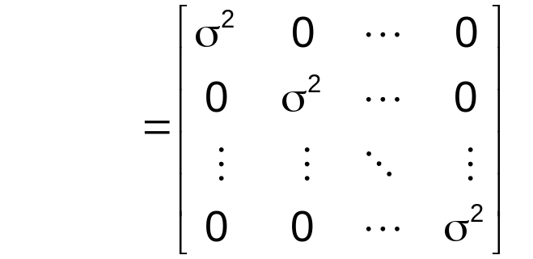= σ²I
since Cov(ε_{i},ε_{i′})=0 (Remember that ε_{i} ~ INDEPENDENT N(0,σ²)).

What is Cov(Y)?

Note that all covariance matrices are symmetric!

Some basic results

Let W = AY where Y is a random vector and A is a matrix of constants (no random variables in it).

The following results follow:
- E(A) = A

Remember this is like saying E(3) = 3

- E(W) = E(AY) = AE(Y)

Again, this is like saying E(3Y₁)=3E(Y₁)

- Cov(W) = Cov(AY) = ACov(Y)A′

You may have seen before that Var(aY₁) = a²Var(Y₁) where a is a constant.

Example:

Let 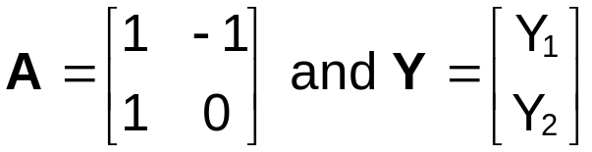. Then 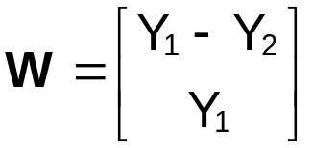.

2.
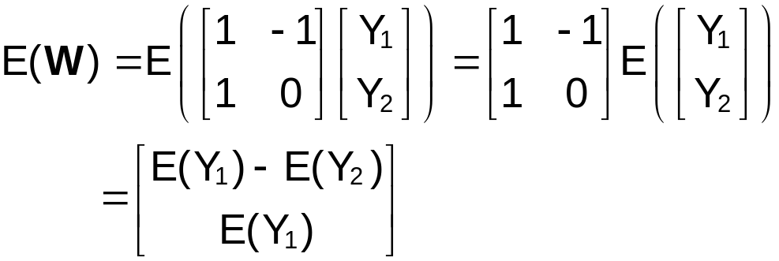

3.
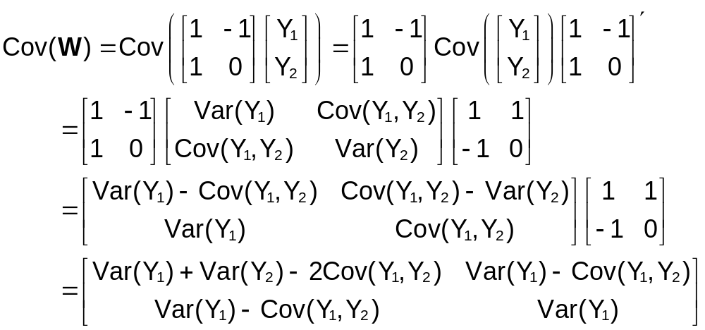
5.9 Simple linear regression model in matrix terms

Y_{i}=β₀+β₁X_{i}+ε_{i} where ε_{i}~ independent N(0,σ²) and i=1,…,n

The model can be rewritten as

Y₁=β₀+β₁X₁+ε₁
Y₂=β₀+β₁X₂+ε₂

Y_{n}=β₀+β₁X_{n}+ε_{n}

In matrix terms, let
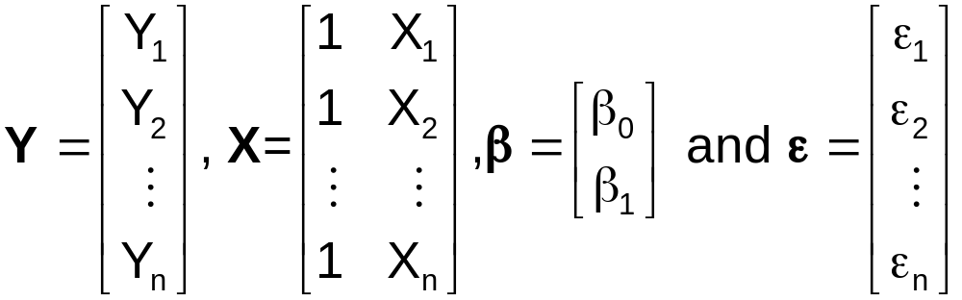

Then Y = Xβ + ε, which is
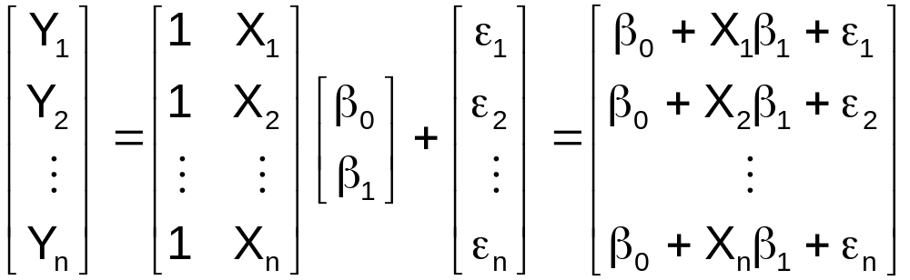

Note that E(Y) = E(Xβ + ε) = E(Xβ) + E(ε) = Xβ since E(ε) = 0 and Xβ are constants.

5.10 Least squares estimation of regression parameters

From Chapter 1: The least squares method tries to find the b₀ and b₁ such that SSE = Σ(Y-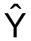)² = Σ(residual)² is minimized. Formulas for b₀ and b₁ are derived using calculus.

It can be shown that b₀ and b₁ can be found from solving the “normal equations”:
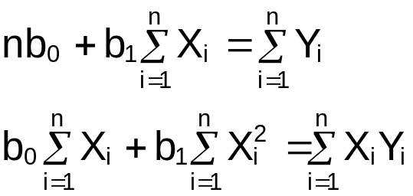

The normal equations can be rewritten as  where 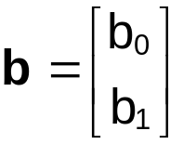. In Section 5.3, it was shown that
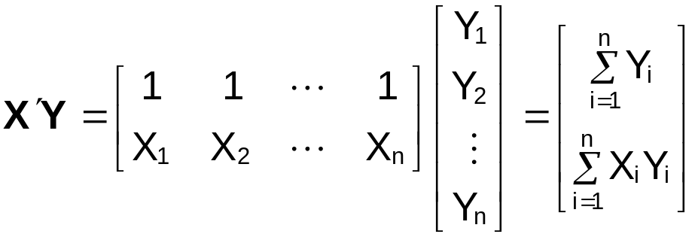 and
X′X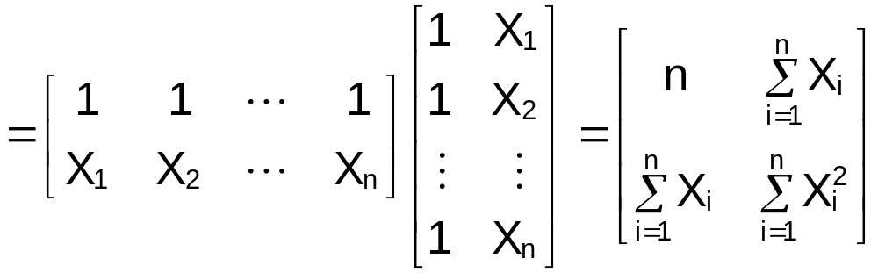.
Thus, can be written as
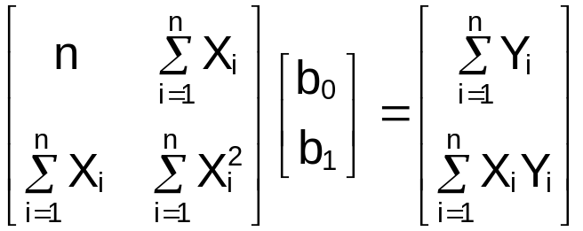
⇔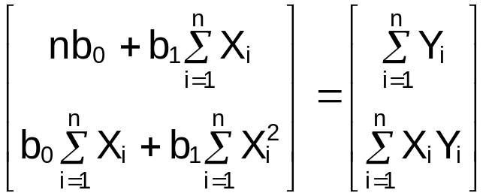

Suppose both sides of are multiplied by (X′X)⁻¹. Then

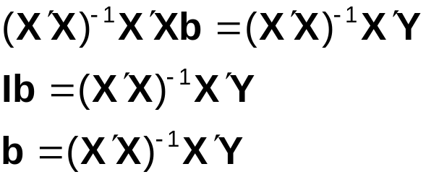

Therefore, we have a way to find b using matrix algebra! Note that

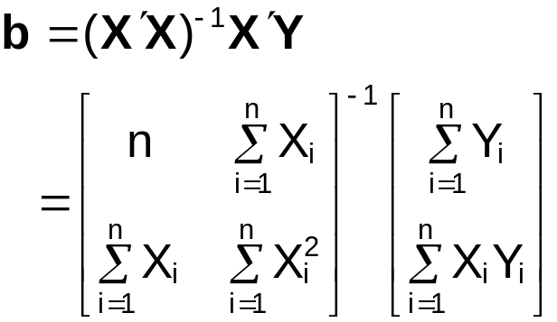
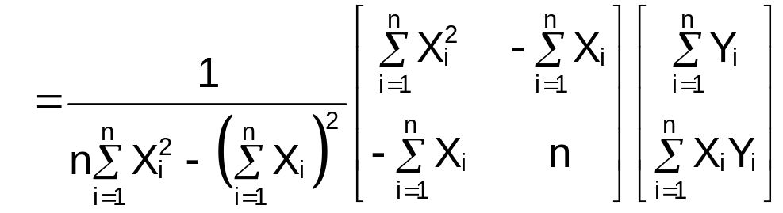
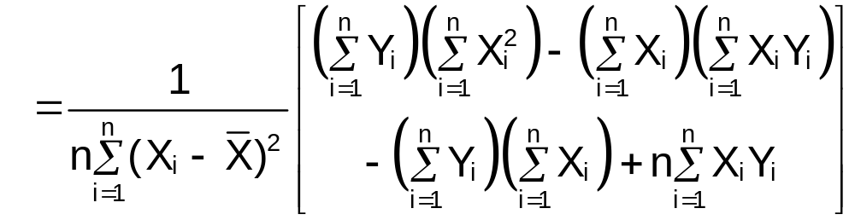
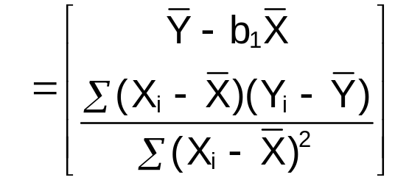

Example: HS and College GPA (HS_college_GPA_ch5.R)

Remember that and
Find 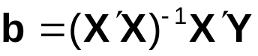. We already did this on p. 5.22.

> solve(t(X)%*%X) %*% t(X)%*%Y
[,1]
[1,] 0.7075776
[2,] 0.6996584

> #Using the formulation of solve for x in Ax = b
> solve(t(X)%*%X, t(X)%*%Y)
[,1]
[1,] 0.7075776
[2,] 0.6996584

From previous output:

> mod.fit<-lm(formula = College.GPA ~ HS.GPA, data = gpa)
> mod.fit$coefficients
(Intercept) HS.GPA
0.7075776 0.6996584

5.11 Fitted values and residuals

Let 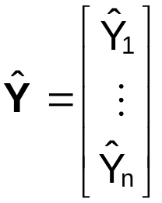. Then 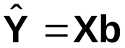 since
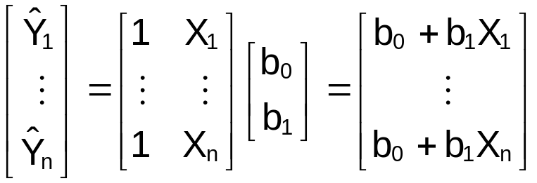

Hat matrix: 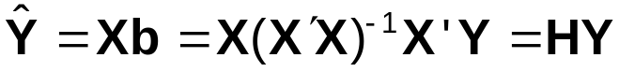 where H=X(X′X)⁻¹X′ is the hat matrix

Why is this called the Hat matrix?

We will use this in Chapter 10 to measure the influence of observations on the estimated regression line.

Residuals:
Let 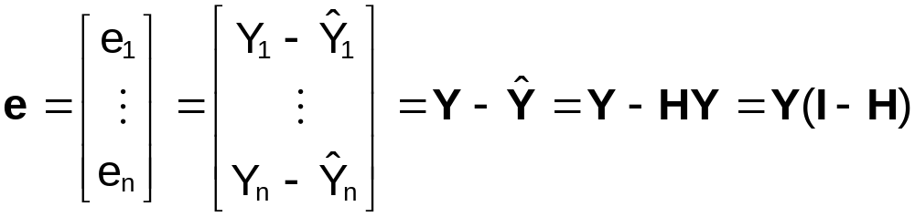

Covariance matrix of the residuals:

Cov(e) = Cov(Y(I-H)) = (I-H)Cov(Y)(I-H)′
Now, Cov(Y) = Cov(Xβ + ε) = Cov(ε) since Xβ are constants. And, Cov(ε) = σ²I

Also, (I-H) = (I-H)′ and (I-H)(I-H) = (I-H). (I-H) is called a symmetric “idempotent” matrix. You can use matrix algebra to see this result on your own (replace H with X(X′X)⁻¹X′ and multiply out).

Thus, Cov(e) = (I-H)σ²I(I-H)′ = σ²(I-H).

The estimated covariance matrix of the residuals is then . Note that KNN would denote 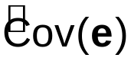 as s²{e}. The notation is more predominantly used.

5.12 Analysis of variance results

Sums of Squares
From Chapters 1 and 2: 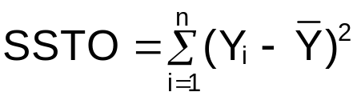, 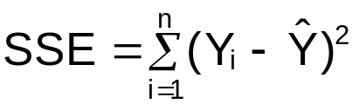, and 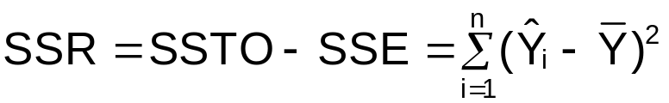

These can be rewritten using matrices:
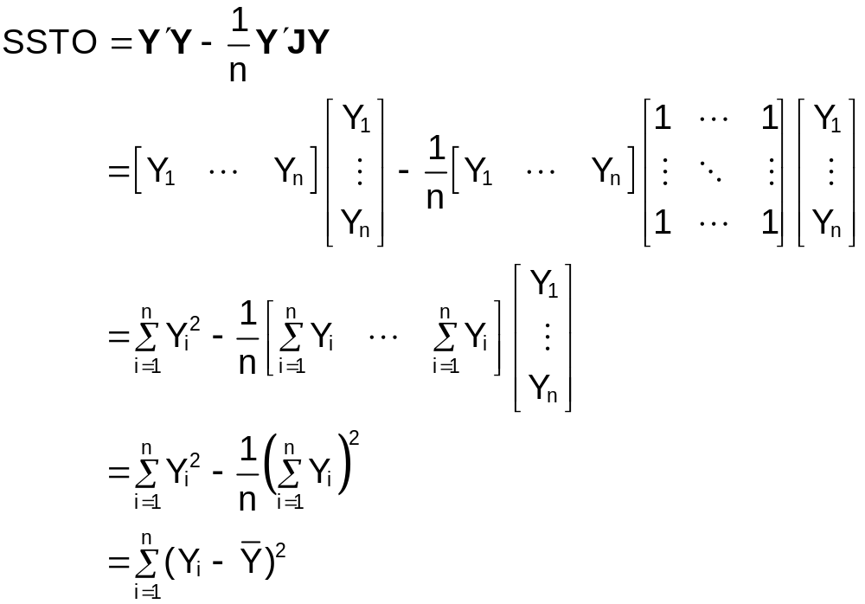
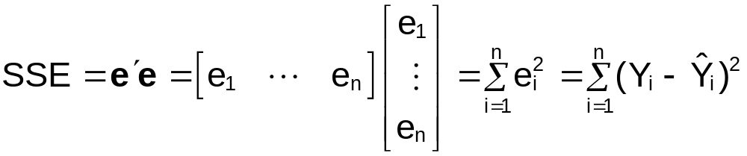


Example: HS and College GPA (HS_college_GPA_ch5.R)

Continuing the same program

> n<-length(Y) #Can not use rows here since R does not
know Y's dimension
> #Could use nrow(X) as well - X is a nx2
matrix
> b<-solve(t(X)%*%X) %*% t(X)%*%Y
> Y.hat<-X%*%b
> e<-Y-Y.hat
> H<-X%*%solve(t(X)%*%X)%*%t(X)

> J<-matrix(data = 1, nrow = n, ncol = n)
> #Notice that R will repeat 1 the correct number of
times to fill the matrix

> SSTO<-t(Y)%*%Y - 1/n%*%t(Y)%*%J%*%Y
> SSE<-t(e)%*%e
> MSE<-SSE/(n-nrow(b))

> #Notice how MSE uses * to do the multiplying since it is
a scalar. Also diag(n) creates an identity matrix.
Diag(c(1,2)) would create a 2x2 diagonal matrix with
elements 1 and 2 on the diagonal
> Cov.e<-MSE*(diag(n) - H) #Does not work!
Error in MSE * (diag(n) - H) : non-conformable arrays

> Cov.e<-as.numeric(MSE)*(diag(n) - H) #The as.numeric()
removes 1x1 matrix
meaning from MSE
> SSR = SSTO - SSE

> data.frame(X, Y, Y.hat, e)
X1 X2 Y Y.hat e
1 1 3.04 3.1 2.834539 0.26546091
2 1 2.35 2.3 2.351775 -0.05177482
3 1 2.70 3.0 2.596655 0.40334475
4 1 2.05 1.9 2.141877 -0.24187731
5 1 2.83 2.5 2.687611 -0.18761083
6 1 4.32 3.7 3.730102 -0.03010181
7 1 3.39 3.4 3.079420 0.32058048
8 1 2.32 2.6 2.330785 0.26921493
9 1 2.69 2.8 2.589659 0.21034134
10 1 0.83 1.6 1.288294 0.31170591
11 1 2.39 2.0 2.379761 -0.37976115
12 1 3.65 2.9 3.261331 -0.36133070
13 1 1.85 2.3 2.001946 0.29805437
14 1 3.83 3.2 3.387269 -0.18726921
15 1 1.22 1.8 1.561161 0.23883914
16 1 1.48 1.4 1.743072 -0.34307203
17 1 2.28 2.0 2.302799 -0.30279873
18 1 4.00 3.8 3.506211 0.29378887
19 1 2.28 2.2 2.302799 -0.10279873
20 1 1.88 1.6 2.022935 -0.42293538

> data.frame(n, SSTO, SSE, MSE, SSR)
n SSTO SSE MSE SSR
1 20 9.6495 1.587966 0.08822035 8.061534

> round(Cov.e[1:5, 1:5],6) #5x5 part of Cov(e)
[,1] [,2] [,3] [,4] [,5]
[1,] 0.082621 -0.003858 -0.004742 -0.003101 -0.005070
[2,] -0.003858 0.083552 -0.004257 -0.005020 -0.004105
[3,] -0.004742 -0.004257 0.083717 -0.004047 -0.004594
[4,] -0.003101 -0.005020 -0.004047 0.082366 -0.003685
[5,] -0.005070 -0.004105 -0.004594 -0.003685 0.083444

> #From past work
> data.frame(X = model.matrix(mod.fit), Y.hat =
mod.fit$fitted.values, e = mod.fit$residuals)
X..Intercept. X.HS.GPA Y.hat e
1 1 3.04 2.834539 0.26546091
2 1 2.35 2.351775 -0.05177482
3 1 2.70 2.596655 0.40334475
4 1 2.05 2.141877 -0.24187731
5 1 2.83 2.687611 -0.18761083
6 1 4.32 3.730102 -0.03010181
7 1 3.39 3.079420 0.32058048
8 1 2.32 2.330785 0.26921493
9 1 2.69 2.589659 0.21034134
10 1 0.83 1.288294 0.31170591
11 1 2.39 2.379761 -0.37976115
12 1 3.65 3.261331 -0.36133070
13 1 1.85 2.001946 0.29805437
14 1 3.83 3.387269 -0.18726921
15 1 1.22 1.561161 0.23883914
16 1 1.48 1.743072 -0.34307203
17 1 2.28 2.302799 -0.30279873
18 1 4.00 3.506211 0.29378887
19 1 2.28 2.302799 -0.10279873
20 1 1.88 2.022935 -0.42293538

> anova(mod.fit)
Analysis of Variance Table

Response: College.GPA
Df Sum Sq Mean Sq F value Pr(>F)
HS.GPA 1 8.0615 8.0615 91.38 1.779e-08 ***
Residuals 18 1.5880 0.0882
---
Signif. codes: 0 '***' 0.001 '**' 0.01 '*' 0.05 '.' 0.1 ' ' 1

5.13 Inferences in Regression Analysis

Covariance matrix of b:
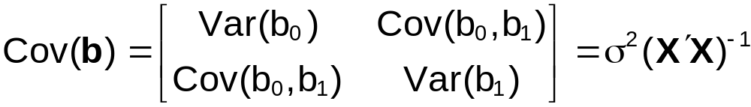

Why?
Cov(b) = Cov[(X′X)⁻¹X′Y]
= (X′X)⁻¹X′Cov(Y)[(X′X)⁻¹X′]′
= (X′X)⁻¹X′Cov(Y)X(X′X)⁻¹
= (X′X)⁻¹X′σ²IX(X′X)⁻¹
= σ²(X′X)⁻¹X′X(X′X)⁻¹
= σ²(X′X)⁻¹

Remember that for two matrices C and B, (CB)′ = B′C′

Estimated covariance matrix of b:
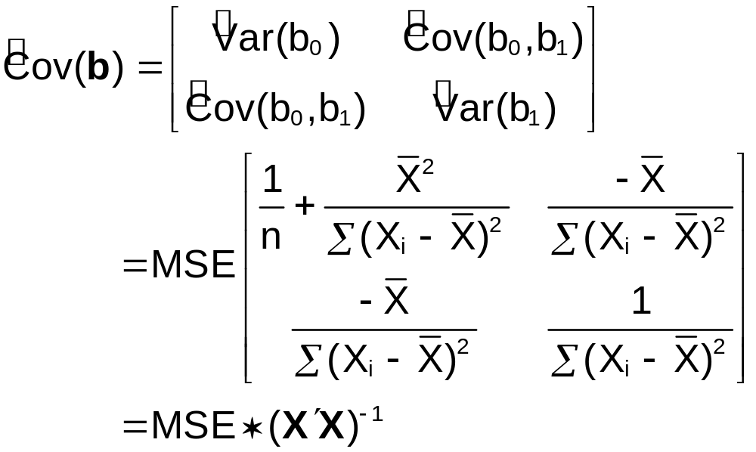
Note that the 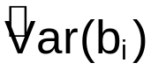 is from Sections 2.1 and 2.2. The 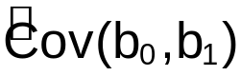 is new.

Estimated variance used in the C.I. for E(Y_{h}):
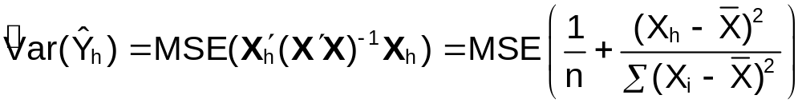
where X_{h} = [1, X_{h}]′

Why?
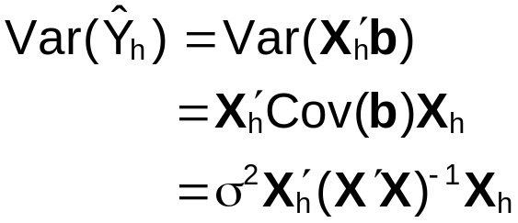

Since b is a vector, I replaced Var() with Cov() (just notation)

Estimated variance used in the P.I. for Y_{h(new)}:
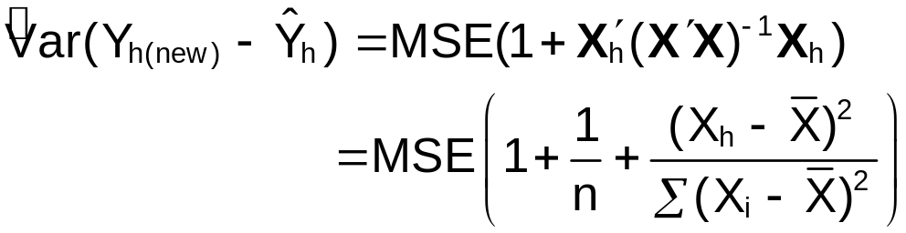

Example: HS and College GPA (HS_college_GPA_ch5.R)

> cov.beta.hat<-as.numeric(MSE)*solve(t(X)%*%X)
> cov.beta.hat
[,1] [,2]
[1,] 0.03976606 -0.013762181
[2,] -0.01376218 0.005357019

> #From earlier
> sum.fit<-summary(mod.fit)
> sum.fit$cov.unscaled #Another way to get (X'X)^(-1)
(Intercept) HS.GPA
(Intercept) 0.4507584 -0.15599781
HS.GPA -0.1559978 0.06072316

> sum.fit$sigma^2 * sum.fit$cov.unscaled
(Intercept) HS.GPA
(Intercept) 0.03976606 -0.013762181
HS.GPA -0.01376218 0.005357019

> #One more way to get the covariance matrix
> vcov(mod.fit)
(Intercept) HS.GPA
(Intercept) 0.03976606 -0.013762181
HS.GPA -0.01376218 0.005357019

> #Find Var(Y^)
> X.h<-c(1,1.88)
> as.numeric(MSE)*X.h%*%solve(t(X)%*%X)%*%X.h
[,1]
[1,] 0.006954107

> #Find Var(Y-Y^)
> as.numeric(MSE)* (1+X.h%*%solve(t(X)%*%X)%*%X.h)
[,1]
[1,] 0.09517446

> #From HS_college_GPA_ch2.R
> n<-nrow(gpa)
> X.h<-1.88
> Y.hat.h<-as.numeric(mod.fit$coefficients[1] +
mod.fit$coefficients[2]*X.h)
#as.numeric just removes an unneeded name
> ssx<-var(gpa$HS.GPA)*(n-1) #SUM( (X_i - X_bar)^2 )
> X.bar<-mean(gpa$HS.GPA)
> MSE * (1/n + (X.h - X.bar)^2 / ssx) #Taken from the
C.I. formula
[,1]
[1,] 0.006954107
> MSE * (1 + 1/n + (X.h - X.bar)^2 / ssx) #Taken from
the P.I. formula
[,1]
[1,] 0.09517446

